Chapter 19, Solution 47.

To get A and C, consider the circuit below.

6

I₁ 1 4 I₂=0

+ + + +
V_{x} 2 5V_{x} V₂
V₁
- - - -

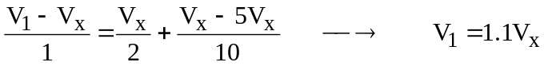

To get B and D, consider the circuit below.

6

I₁ 1 4 I₂

0V
+ + + +
V_{x} 2 5V_{x} V₂=0
V₁
- - - -

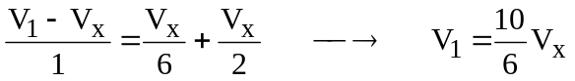 (1)

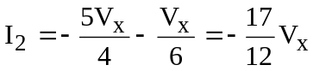 (2)

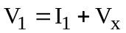 (3)

From (1) and (3)

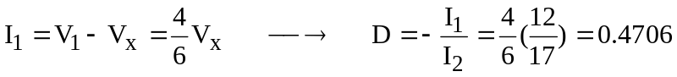

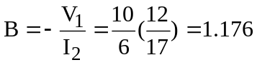
S
Ω
